YUSUF MAITAMA SULE UNIVERSITY, KANO.
COMPUTER SCIENCE DEPARTMENT
CSC 44O1 (SOFTWARE ENGINEERING)
PROJECT: ESTATE MANAGEMENT SYSTEM
GROUP MEMBERS
SN | NAME | REG NO
1 | KHALIL KABIR MUSA | UG18CSC2069
2 | MUHAMMAD JUNAIDU SANI | UG18CSC2068
3 | ALI MUSA BAFFA | UG18CSC2080
4 | IBRAHIM MUHAMMAD BAKO | UG18CSC2076
5 | SAGIR JIBRIN YAU | UG18CSC2098
6 | SABIU IBRAHIM NASIDI | UG18CSC2070
7 | IBRAHIM ALI USMAN | UG18CSC2099
8 | MARIYA TAHIR LAWAL | UG16CSC070
9 | RUKHAYYAH SA’ED SAIF | UG17CSC1047
10 | YUSUF AHMAD ABDULLAHI | UG17CSC1003
11 | UMMI GARBA | UG18CSC2072

CHAPTER ONE
INTRODUCTION
1.1 Introduction
An estate can be defined as an area or amount of land or property. Estate management is quite a broad term for a number of areas that include property management, surveying, business and finance and the built environment. Closer ties are beginning to emerge between estate and property management and business and financial practices, and essentially the subject is primarily concerned with the valuation and management of buildings in the public and private sector. With house prices rising at an astonishing rate over the last few years and now the recession, the government has come under increasing pressure to be relieved from a 'housing crisis'. This crisis has come about because of the rise in house prices which first-time buyers can no longer afford and a lack of affordable housing for the citizens. All of this has become an area of tremendous interest. The government has predicted that more homes are needed, but where these houses are to be built has also courted controversy. Based on the size of the property, the Estate Manager may wear many other hats. Depending on the nature of the property, an owner of property has the right to consume, sell, and/or to exclude others from doing these things. A title, or a right of ownership, establishes the relation between the property and other persons, assuring the owner the right to dispose of the property as they see fit. Some philosophers assert that property rights arise from social convention. Others find origins for them in morality or natural law. So, estate management system is needed to take care of keeping records of the estate transactions in term of sale of a property. Maintaining such record manually will be cumbersome hence the need for an estate management system that will automate all estate transactions. This research work is sub divided into THREE chapters as follows: chapter one which contains the introduction of the work, Chapter two contains functional and nonfunctional requirements of the system. Chapter three contains the analyses and design of the proposed system.
1.2 Background Of The Study
Land use, land valuation, and the determination of the incomes of landowners, are among the oldest questions in economic theory (Shavell, 2004). Land is an essential input (factor of production) for agriculture, and agriculture is by far the most important economic activity in preindustrial societies. With the advent of industrialization, important new uses for land emerged, as sites for factories, warehouses, offices, and urban agglomerations. Also, the value of real property taking the form of man-made structures and machinery increases relative to the value of land alone. The concept of real property eventually comes to encompass effectively all forms of tangible fixed capital. With the rise of extractive industries, real property comes to encompass natural capital. With the rise of tourism and leisure, real property comes to include scenic and other amenity values. Starting in the 1960s, as part of the emerging field of law and economics, economists and legal scholars began to study the property rights enjoyed by tenants under the various estates, and the economic benefits and costs of the various estates, Epstein (2007). This resulted in a much improved understanding of the:
Property rights enjoyed by tenants under the various estates. These include the right to:
· Decide how a piece of real property is used;
· Exclude others from enjoying the property;
· Nature and consequences of transaction costs when changing and transferring estates.
1.3 Statement of Problem
Housing is a basic need for all. Over the years, increase in population and income has led to an equivalent increase in housing demand. Managing these demands manually will pose great challenges and difficulties; hence there is a need to automate the management process. Keeping record in an estate concerning buildings and their owners has been a great task to the government and the governed. Access to estate information proves difficult that most times people are defrauded due to lack of property information. Illegal sales of houses without the consent of the owner are very common. Hence the need for computerization of estate management system.
1.4 Aim and Objectives of The Study
The aim of this research work is to develop a real estate management system to make estate information accessible to both government and individuals who may like to acquire building property.
The objectives of this study are as highlighted below;
1. To develop a software that will keep information on house size, house location and house owners in an estate
2. Handle details for sale of property from clients.
3. Carry out data analysis and statistical inference.
3. Produce financial and customer reports with detailed statistical analysis.
4. Provide security to the client’s data.

1.5 Significance of the Study
This research work is of great importance in that it seeks to provide innovative services relating to estate management such as providing information on estate use as quickly as possible. Other significances it offers are found in the following areas;
1. Updating and modification of information concerning buildings in an area.
2. Faster and easier retrieval of estate information for instantaneous use of recipient such as government agencies, demographers, tourists and individuals.
4. Keep a database of all the buildings in an estate
5. Guide buyers on how to buy property and who to meet.
6. Educate buyers on the type of house to build in an area for proper estate planning.
7. It will also aid in urban and regional planning.

1.6 Scope of the Study
Every project is carried out to achieve a set of goals with some conditions keeping in mind that it should be easy to use, feasible and user friendly. As the goal of this project is to develop an application to manage real estate efficiently, this system will be designed keeping in mind the conditions (easy to use, feasibility and user friendly) stated above. The proposed project would cover:
1. Developing a software to effectively manage real estates
2. Implementing it on a computer system.
1.7 Definition of Terms
ESTATE: An Estate can be seen as a property to which a person is lawfully entitled. In traditional law, it refers to property in land; a person’s Estate consists of the interest or rights that the person held in land.
MANAGEMENT: Management is the function that coordinates the efforts of people to accomplish goals and objectives by using available resources efficiently and effectively. It includes planning, organizing, staffing, leading or directing, and controlling an organizationor a system to accomplish a goal.
PROPERTY: Property is one or more components (rather than attributes), whether physical or incorporeal, of a person's estate; or so belonging to a person or jointly owned by a group of people or a legal entity like a corporation or even a society.
GIS: A geographic information system (GIS) is a system designed to capture, store, manipulate, analyze, manage, and present all types of spatial or geographical data. In a general sense, the term describes any information system that integrates, stores, edits, analyzes, shares, and displays geographic information.
SURVEY: This can be seen as the mapping of the properties and varieties of soil in a given area. It could also mean the locating of structures relative to a reference line, used in the construction of buildings, roads, mines, and tunnels.
AUTOMATION: Automation is the use of various control systems for operating equipment or applications with minimal or reduced human intervention.
SYSTEM: A system is a set of interacting or interdependent components forming an integrated whole. Every system is delineated by its spatial and temporal boundaries, surrounded and influenced by its environment, described by its structure and purpose and expressed in its functioning.

CHAPTER TWO
REQUIREMENT ENGINEERING
Functional requirements
ADMIN
- The system shall allow the super admin to authenticate
- The admin should be allowed to view admin dashboard
- The admin should be allowed to update his profile
- The system shall allow admin to add new admin
- The admin should be able to see all administrators
- The admin should be allowed to view users activity logs
- The admin should be allowed to view admins activity logs
- The admin should be allowed to delete user activity logs
- The admin should be allowed to manage transactions
- The admin should be allowed to manage charges
- The admin should be authorized to pay bonus to customers
- The admin should be allowed to view sales report
- The admin should be allowed to view user record
- The admin should be allowed to view verified users
- The admin should be allowed to view unverified users
- The admin should be allowed to verify users
- The admin should be allowed to contact the property buyer
- The admin should be allowed to view customers feedbacks
- The admin should be allowed to log out from the system
BUYER
- The new buyer should be allowed to create account
- The buyer shall only be registered when complied with terms and conditions
- The buyer should be allowed to authenticate
- The buyer should be allowed to view his dashboard
- The buyer should be authorize to update his profile
- The buyer should be authorize to create a wallet
- The buyer should be allowed to recharge wallet
- The buyer should allowed to view wallet current balance
- The buyer should be allowed to view property adverts
- The buyer should be allowed to search property
- The buyer should be allowed to select the desired property
- The buyer should be authorize to view property details
- The buyer should not be allowed to change property price
- The buyer should be allowed to view property owner details
- The buyer should be allowed to buy property
- The buyer should be allowed to pay either from wallet or vogue pay
- The buyer should receive the payment receipt
- The buyer should receive ownership certificate after payment
- The buyer should be allowed to contact SYI estate management
- The buyer should be allowed to send feedback to SYI estate management
- The buyer should be allowed to log out from the system
PROPERTY OWNER
- The property owner should be allowed to create an account
- The property owner shall only be registered if complied with terms and conditions
- The property owner should be allowed to authenticate
- The property owner should be allowed to update profile
- The property owner should be allowed to upload properties
- The property owner should be allowed to upload property ownership certificate
- The property owner should be allowed to provide exact property description
- The property owner should be allowed to create a wallet
- The property owner should be allowed to recharge his wallet
- The property owner should be allowed to view his current balance
- The property owner should be allowed to add bank details
- The property owner shall pay 10% of property price for property adverts
- The property owner should be allowed to pay from wallet or on vogue pay
- The property owner should receive payment receipt
- The property owner should be allowed to request for bonus
- The property owner should be allowed to contact SYI estate management
- The property owner should be allowed to send feedback to SYI estate management
- The property owner should be allowed to log out from the system
SYSTEM
- The system shall allow the admin to register, either as property owner or property buyer
- The system shall only register property owner when he upload property valid identification
- The system shall only accept property valid identification file in PDF format
- The system shall allow only property with ownership certificate to be uploaded
- The system shall only upload a property advert whose property advert payment has been made
- The system shall provide the best time for the users to contact SYI estate management
- The system shall provide SYI estate management location
NON-FUNCTIONAL REQUIREMENTS/ CONSTRAINTS
- The payment receipt must be sent immediately after each payment
- The system shall be portable
- The system shall be reliable to its users
- The system shall be efficient
- The system should be consistent
- The user address must exceed 6 characters
- The user phone number must be eleven digits
- The user must provide his/her address before being able to register
- The system must provide sales report everyday
- The system must provide weekly sales report

CHAPTER THREE
SYSTEM MODELLING AND DESIGN

ACTIVITY DIAGRAM

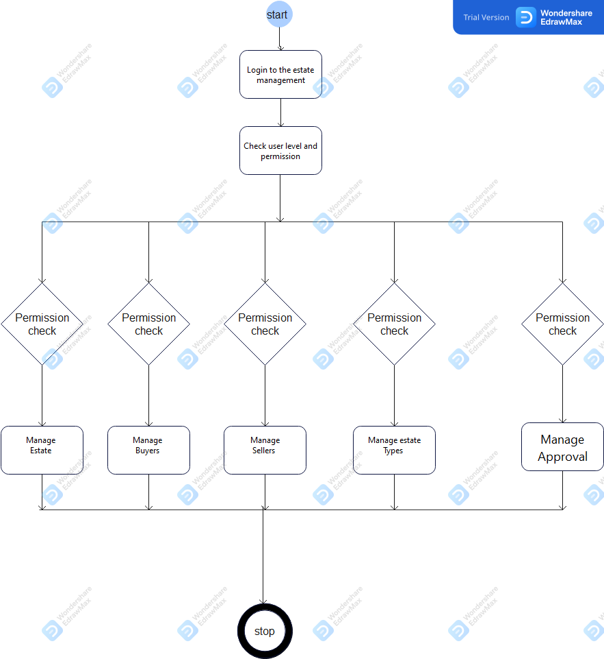

USE CASE DIAGRAMS

1. ADMIN USE CASE DIAGRAM
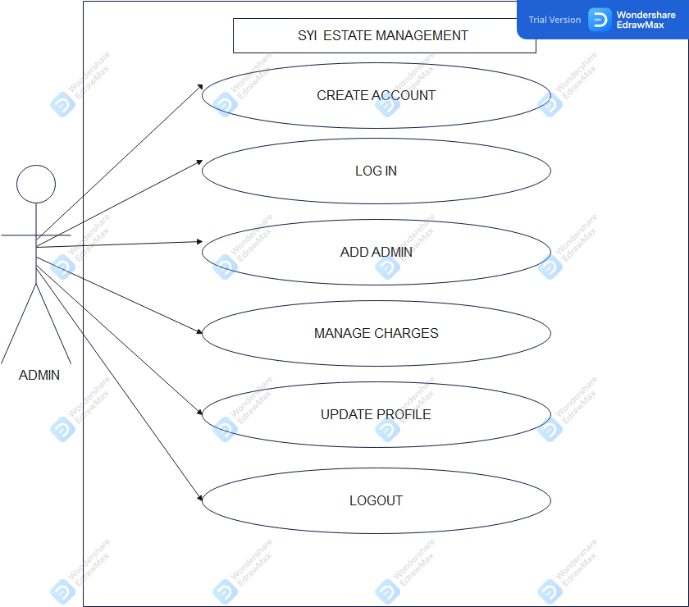

2. PROPERTY OWNER USE CASE DIAGRAM
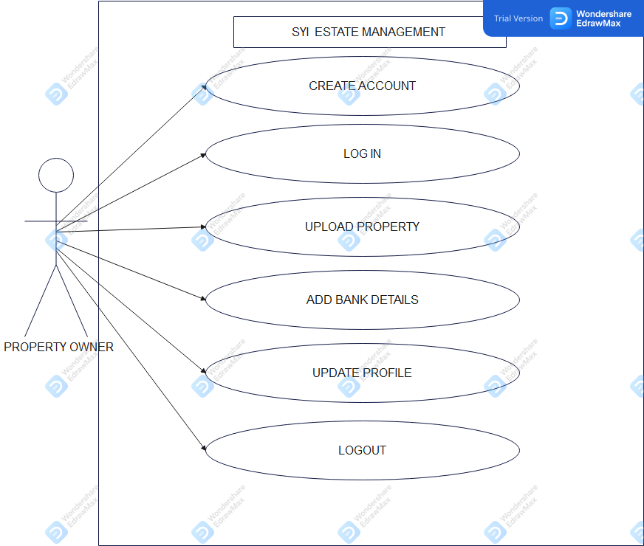

3.0 PROPERTY BUYER
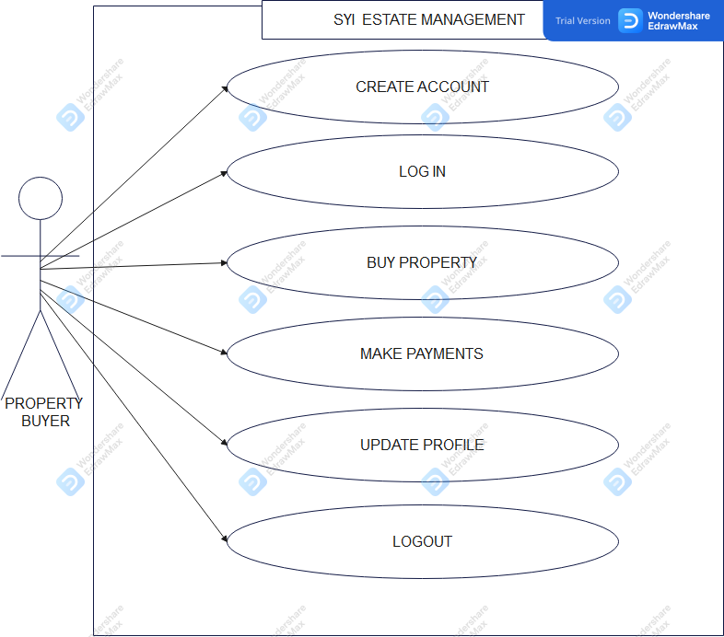

4.0 ADD PROPERTY USE CASE DIAGRAM
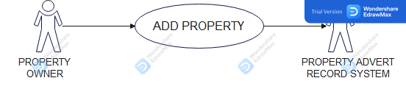

ACTORS | Property owner, property advert record system
DESCRIPTION | The property owner may be able to add a property to the property advert record system, the property added should be along with the description of the property which include (property address, property price, property type etc.).
DATA | Property type, property address, property price.
STIMULUS | Description of the property by the property owner.
RESPONSE | Confirmation of property uploaded by the admin
COMMENTS | The property owner must have permission to access to the PARS.

SEQUENCE DIAGRAM

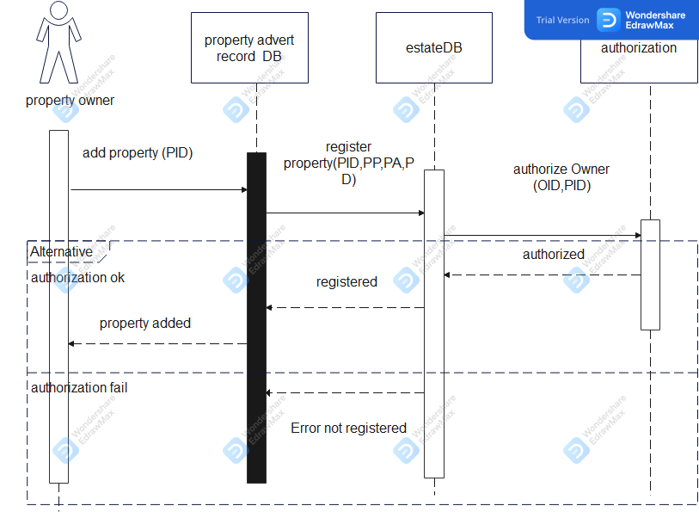

CLASS DIAGRAM
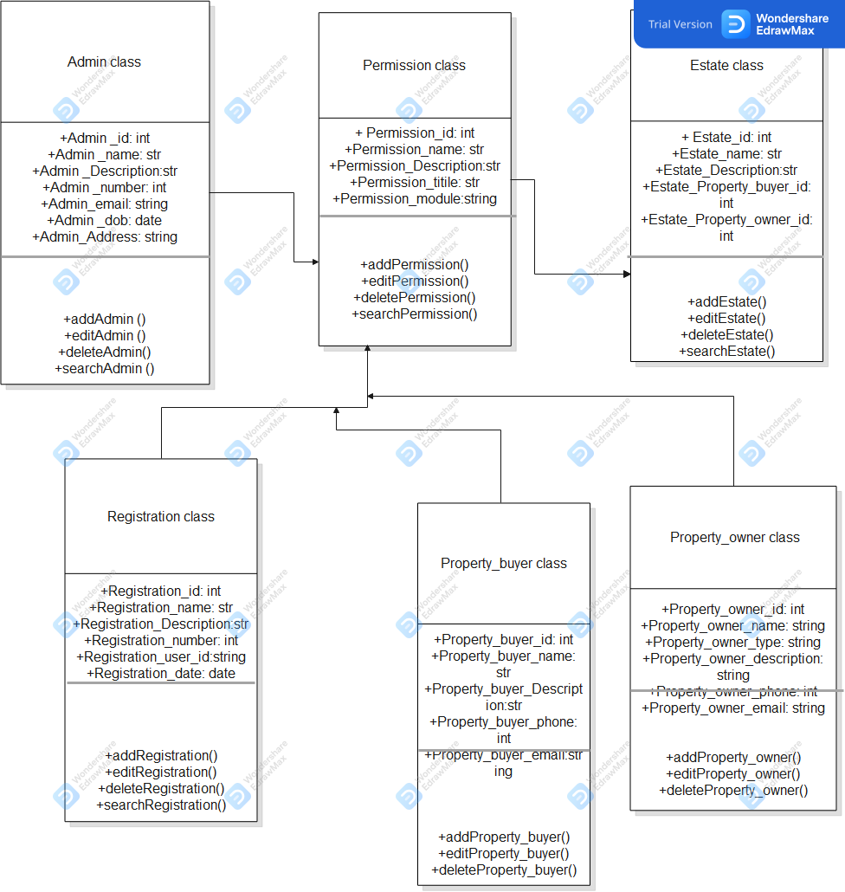

SYSTEM ARCHITECTURE

